Project 2:

Contextual Inquiry and Contextual Analysis

Simplified Sckhaedgeuler (SS)

Snow College

*Synthesis of collected data on current scheduling implementations.*

Leedan Johnson, Alex Thayn, Jackson Porter

Table of Contents

1. System Concept Statement
2. Scope of the Project
3. Preparation
4. Participants & Questions
5. Initial Questions
6. Interviews & Workshops
7. The WAAD
8. Diagrams and Models
9. Photos
10. In-Field Sketches
11. Sample Task Data
12. Raw Data
13. WAAD Process
14. WAAD Pictures
15. Photos of WAAD
16. Work Roles

17-21: Diagrams & Models

# 1. System Concept Statement:

The Simplified Sckhaedgeuler (SS) provides simple and efficient room scheduling for large organizations. SS is easy to learn, and easier to use. With many points of access including a web portal, scheduling a room couldn’t be easier. Existing room schedulers and building administrators will be allowed to retain whatever measure of control they desire, or they can let SS handle it autonomously. Users will love the many built-in smart features, including email confirmations and reminders. Feedback and maintenance is also handled effortlessly, allowing users to report issues which will be instantly made known to management, and other room reservees. In short, the Simplified Sckhaedgeuler overcomes the challenges of traditional room management, allowing the process to be effortless and enjoyable.

# 2. Scope of the Project:

During this project, our original ideas and thought process were greatly modified and views were changed. At first, we had a set of ideals that put us in the shoes of the user and super interfaces that we wanted implemented. After talking to participants and learning more about the current system our views changed. From that point on, we tried to put ourselves in the shoes of all of the users of the system, thus creating a system idea that was better for all users of the software. We asked each kind of user what they were looking for in order to come up with the best idea and get the best feedback from our users.

# 3. Preparation:

For the interview process, we all began with some initial research on our own to better understand the current context of the scheduling system and other solutions out there. Next we each came up with our own set of interview questions to help guide the interviews. Then we scheduled the interviews and began with our questions, but also went with the flow of the conversation to see where the interviewees would lead us, in hope of gaining a better understanding of what the process looks like to them.

Preparation for the workshop began with our group going over the user centered business canvas and filling it out to the best of our ability with our current understanding of the system. Our goal for the workshop was then to finish filling out the user centered business canvas. We began the workshop with an explanation of the business canvas, and guided the workshop to help us fill in the gaps we had left. We were able to gain further insight about the current system along the way.

# 4. Our Participants

We had many participants in this project. They were vital assets to our projects.

For our initial interviews, we had the following participants:

* Margie Anderson - Assistant Registrar & Manager of Room Scheduling (Assistant Registrar at Current Educational Institution)
* Mikah Strait - Snow College Registrar (Registrar at Current Educational Institution)4
* Ty Bayn, Nathan Hebert - Snow College Students (Classmates)

For our workshop, we had the following participants:

* Heber Allen - A Current Professor at Snow (Current Professor at Educational Institution)
* Michael Lewellen - Library Worker (Classmate/Associate)
* John Ostler - Library Director (Current Institution’s Library Director)

# 5. Our Initial Questions

Questions:

* What room reservation system does your organization currently employ?
* Have you, or are you using another system either now or previously?
* How effective do you think the system is?
* How much time would you say it takes you to reserve a room?
* How reliable do you believe the system to be? Have you had any issues personally?
* Could you share with us the worst experience you had with the system, and what made it a negative experience?
* Could you also share with us the best experience you’ve had, and what made it satisfying?
* Would you be willing to try a new system?
* Would you want a new room scheduling program to integrate with your current calendar/agenda solution?
* Would you be open to having a online/mobile solution that those wanting to schedule the room could use instead of going through a “building scheduler?”
* Do you feel as though Snow College is small enough it would *not* benefit from another implemented solution?
* How do you currently schedule a room?
* What is the hardest part of scheduling a room?
* How would you like to see the process of scheduling a room changed?
* What do you like about the current reservation process?
* Are you aware of any existing solutions out there to assist in the room scheduling process?

# 6. Interviews

Our first meeting was with a group of students where we were able to ask about their interpretation of the scheduling system and how they used it. Our second was with two system administrators which ended up largely affecting our understanding of the system and broadened the scope of our project. The meetings went well and we were able to answer not only our initial question, but also begin to understand more about the process of scheduling rooms than we even knew existed.

# 7. Collection of Raw Data

We made use of several mediums in gathering contextual data. During the interviews, we captured an audio recording to ensure we could review the interviewee’s exact words when needed. We also kept notes during the interviews, and on a limited scale, used diagrams for clarity.

# 

# 

# 8. Work Artifacts

We did not obtain images of the Banner system, but we can show you what an Exchange (Outlook) Calendar and Google Calendar look like:

**Microsoft Outlook (Exchange) (image from:** [**https://exchangeshare.wordpress.com**](https://exchangeshare.wordpress.com)**)**

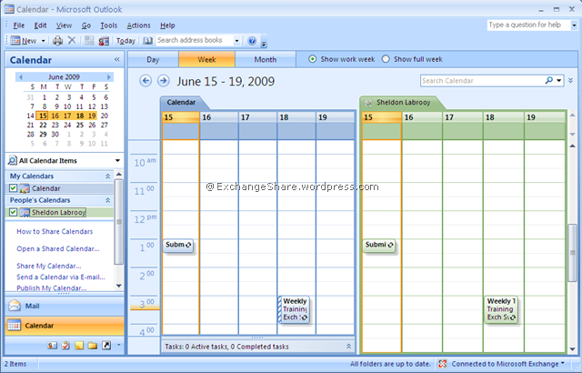

**Google Calendar (image from** [**http://cdblog.centraldesktop.com**](http://cdblog.centraldesktop.com)**)**

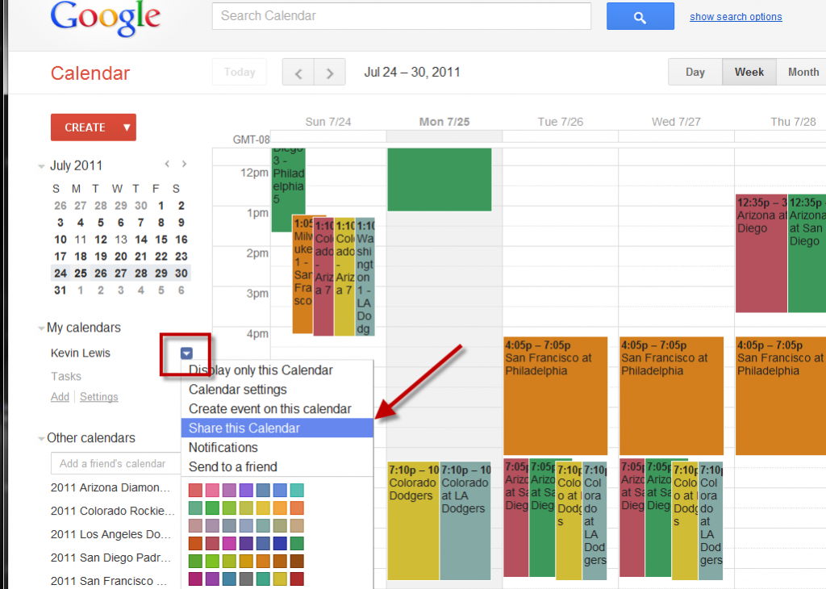

# 9. Photos (see WAAD)

# 

# 

# 10. In-field sketches

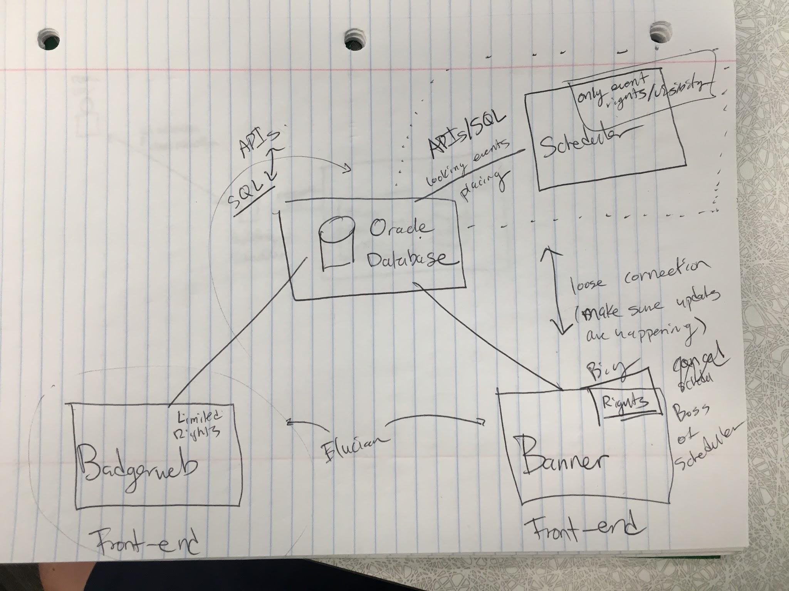

# 

# 

# 11. Sample Task Data

Events can usually be scheduled within one minute

Events are labeled as a different types

Dates are entered

Times they want

Room wanted

Conflict Management is built in

Each department schedules their own classes

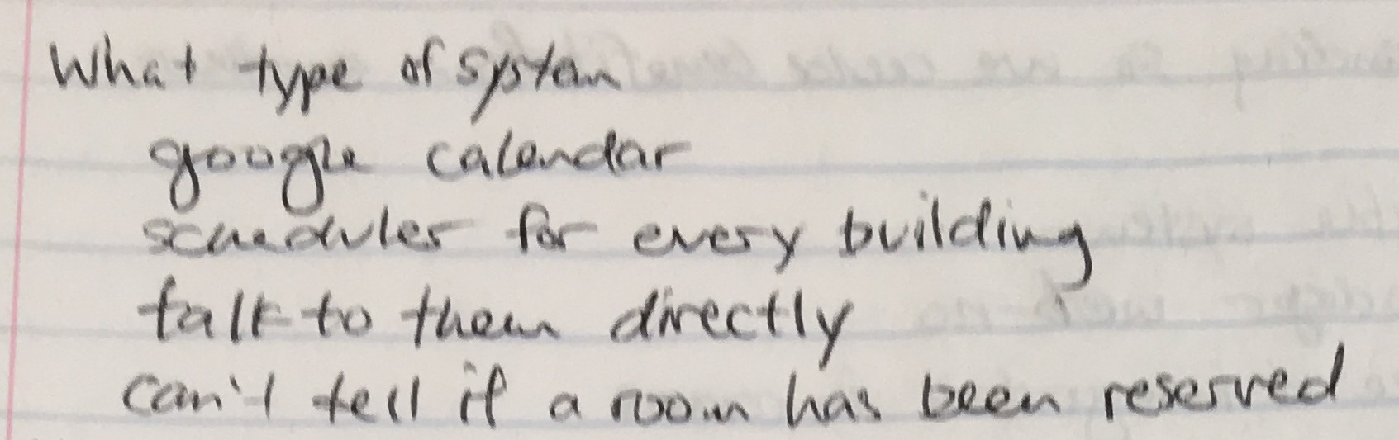

(From our interview with Ty, Nathan and Ammon)

# The WAAD (Work Affinity Activity Diagram)

# 12. Raw Data and Corresponding Activity Notes

Show samples ( a dozen or so) of your raw data notes and the corresponding work activity notes you extracted.

Ty - As far as I know, from what I've been told, there is a google calendar, and that is it. So every building controls their own scheduling. There is a scheduler, person, for every building that you can talk to.

[I1 00:27] As far as I know the current scheduling system consists of a Google calendar.

[I1 00:30] Every building is scheduled independently of the others by a building scheduler.

Ty - Um, it's meh, it's meh effective because you can get the room reserved, and they can get things setup for you, and it's nice cause if someone tries to kick you out you can say uh, uh, uh, I have a reservation. And you can keep the room, but it's really frustrating when you want a room and you don't know if it's reserved or not, and it's kind of a pain to have to go up to the second floor, northwest corner of the building and talk to Mike and say "Hey is this room reserved?" So I mean it kind of works, but it's hard to communicate. People don't know or not unless they've recently reserved something. It's less than mediocre.

[I1 00:57] There’s no way for a user to know which rooms are available and which are reserved.

[I1 01:39] It's really frustrating when you want a room and you don't know if it's reserved or not.

[I1 01:26] The current system is somewhat effective because you can get the room reserved, and you hopefully won’t get kicked out if you have a reservation.

[I1 01:42] It's kind of a pain to have to go up to the second floor, northwest corner of the building and talk to mike and say "Hey is this room reserved?" So I mean it kind of works, buts it's hard to communicate.

Nathan - Yeah so if I look at it and ask like, "oh what are the rooms," and then I check and see if anyone reserved it, and just walked up the stairs, it's not that difficult. It doesn't really matter which room it is for the most part, some of them are bigger than others, but like that could be information that the service would provide. Let's say like this room has, how many seats in it.

[I1 16:30] I want a uniform and consistent interface so the experience is the same wherever you access the system.

[I1 22:58] I think there should be a website available so we can make reservations from anywhere.

[I1 24:00] I want to know when a room is vacant.

# 13. WAAD Process

For each activity we did in the contextual inquiry phase we had recordings we were able to go back and listen to. We extracted the work activity notes from these recordings and any of the corresponding notes we took during the interview and workshop sessions. We decided to throw all the work activity notes into an online program to simulate having post it notes for each activity note. We then met together as a group and sorted all the work activity notes together into different bins and created a tree structure of organized work activity notes.

# 14. WAAD Work Pictures

*We did not have any pictures of us at hard work, but the WAAD will reflect us doing so!*

# 15. Photos of WAADWAAD (1).jpg WAAD (2).jpg

# 16. Major Work Roles

Major work roles:

* Registrar
* Student
* Faculty
* Building/Department Manager
* Outside Network
* Central Scheduler (Proposed flow model)

Machine roles:

* Database

# 

# 

# 17-21 Diagrams and Models

**Our Personas: